Integrating the Healthcare Enterprise



IHE Patient Care Coordination (PCC)

Technical Framework Supplement

Cross-enterprise Tumor Board Workflow Definition
(XTB-WD)

Public Comment

Date: January 23rd 2012
Authors: Vincent van Pelt, Robert Breas, Hans Mekenkamp, Ronald Vlaanderen
Co-authors: Luca Zalunardo, Arianna Cocchiglia
Version: v0.3.5.8, April 11th, 2012
Status: Draft
Email: ihe@himss.org
Foreword
This page is standard language for all IHE supplements. The Introduction section following will list all other IHE documents that are modified by this supplement. This document is a supplement to the IHE PCC Technical Framework Revision 7.0 The technical framework can be found at http://www.ihe.net/Technical_Framework/index.cfm#pcc.
This and all IHE supplements are written as changes to a base document. The base document is normally one or more IHE Final Text documents. Supplements tell a technical editor and the reader how to modify the final text (additions, deletions, changes in wording). In order to understand this supplement, the reader needs to read and understand all of the base documents that are modified by this supplement.
In this supplement you will see “boxed” instructions similar to the following:
Replace Section X.X by the following:
These “boxed” instructions are for the author to indicate to the Volume Editor how to integrate the relevant section(s) into the overall Technical Framework.
This format means the reader has to integrate the base documents and the supplement. When the material in the supplement is considered ready for incorporation into the final text of the Technical Framework, the IHE committees will update the technical framework documents with the final text. Supplements are written in this format to avoid duplication material. This means that two IHE documents (one possibly final text, and the other a supplement) should not contain contradictory material.
Text in this document is not considered final for the Technical Framework. It becomes Final Text only after the IHE PCC Technical Committee ballots the supplement (after testing) and agrees that the material is ready for integration with the existing Technical Framework documents.

It is submitted for Public Comment starting <Month XX, 20XX>
Comments on this supplement may be submitted to http://forums.rsna.org:
- Select the “IHE - Integrating the Healthcare Enterprise” forum
- Select “PCC Technical Framework“
- Select “2012 Supplements for Public Comment”
- Select Cross-enterprise Tumor Board Workflow Definition

Please use the Public Comment Template provided there when starting your New Thread.

Details about IHE may be found at: www.ihe.net
Details about the IHE Patient Care Coordination may be found at: http://www.ihe.net/Domains/index.cfm
Details about the structure of IHE Technical Frameworks and Supplements may be found at: http://www.ihe.net/About/process.cfm and http://www.ihe.net/profiles/index.cfm

TABLE OF CONTENTS

IHE Patient Care Coordination (PCC) 0
Technical Framework Supplement 0
Public Comment 0
Introduction 5
Open Issues and Questions 5
Closed Issues 7
Volume 1 – Profiles 13
1.1 Copyright Permissions 13
1.2 Dependencies of the PCC Integration Profiles 13
1.3 History of Annual Changes 13
2 Introduction to the Cross-enterprise Tumor Board Workflow Definition Profile 14
2.1 Purpose 14
2.2 Scope 15
2.3 Process Flow 16
2.3.1 Stages of a Tumor Board Review process 16
2.3.2 Analysis of the current situation 18
2.3.3 Diagrams 20
3 XDW Content Profile 21
3.1 Actors / Transactions XDS 21
3.1.1 Cross-Enterprise Document Workflow Profile Options 22
3.1.2 View Option Fout! Bladwijzer niet gedefinieerd.
3.1.3 Document Import Option Fout! Bladwijzer niet gedefinieerd.
3.2 XDW Actor Grouping and Profile Interactions Fout! Bladwijzer niet gedefinieerd.
3.3 XDW Process Flow Fout! Bladwijzer niet gedefinieerd.
3.3.1 XDW Approach to Workflow Fout! Bladwijzer niet gedefinieerd.
3.3.2 XDW Workflow Architecture Fout! Bladwijzer niet gedefinieerd.
3.3.3 XDW Document Structure Fout! Bladwijzer niet gedefinieerd.
3.3.4 XDW Use-Cases and Process Flow in an XDS Affinity Domain 23
This use case is not intended as a Workflow Definition Profile specification. Such Profiles are expected to be developed by clinical IHE Domains in order to support their specific workflows. Fout! Bladwijzer niet gedefinieerd.
3.3.5 Referral Workflow Use Case 23
3.3.6 Referral Workflow Use Case - Step by Step 24
3.4 XDW Security Considerations 25
3.5 Options for Workflow definitions 25
4 XTB-WD Workflow Definition Profile 27
4.1 Rules for Workflow Definition of XTB-WD 27
4.1.1 Actors and Grouping 27
4.1.2 XDW Workflow Document – Common Attributes 28
4.1.3 Workflow Task Definition 28
4.1.4 Task: Request TBR 30
4.1.5 Task: Schedule TBR 32
4.1.6 Task: Prepare TBR 34
4.1.7 Task TBR Meeting 36
4.1.8 Task Finalize TBR 39
4.2 Groupings 41
4.3 Security Considerations 41
4.4 Content Modules 41
Glossary 43
Volume 2 – Transactions and Content Modules 44
5 IHE Transactions 45
5.1 <Transaction Name> 45
5.1.1 Scope 45
5.1.2 Use Case Roles 45
5.1.3 Referenced Standard 45
5.1.4 Interaction Diagram 46
5.1.5 Security Considerations 47
6 Namespaces and Vocabularies 48
6.1 IHE Format Codes 48
7 PCC Content Modules 49
7.1 Folder Content Modules 49
7.1.1 <Folder Specification Name> 49
7.2 HL7 Version 3.0 Content Modules 49
7.2.1 CDA Document Content Modules 49
7.2.2 CDA Header Content Modules 49
7.2.3 CDA Section Content Modules 50
7.2.4 CDA Entry Content Modules 50
7.3 PCC Value Sets 50
7.3.1 <Value Set Name> 50
8 Appendix A – Example of a Nested set of Workflow Definitions 51

Introduction
This supplement is written for Public comment. It is written as addition to the documents listed below. The reader should have already read and understood these documents:
- PCC Technical Framework Volume 1, Revision 7.0
- PCC Technical Framework Volume 2, Revision 7.0
This supplement also references other documents. The reader should have already read and understood these documents:
- IT Infrastructure Technical Framework Supplement Cross-enterprise Document Workflow (XDW)
- IT Infrastructure Technical Framework, Latest Revision
- The Patient Identifier Cross-Reference (PIX) and Patient Demographic Query (PDQ) HL7 v3 Supplement to the IT Infrastructure Technical Framework.
- HL7 and other standards documents referenced in Volume 1 and Volume 2

Issues and Questions
Introduction
This proposal arises from the necessity of different actors to manage the Tumor Board workflow. Looking at the process, both the workflow and the content form an integral part of this process. We therefore propose to combine an XDW Definition profile and PCC Content Integration Profile to define the Care Pathway for a Tumor Board review.
The value statement of this proposal is:
- the creation of a workflow definition for the management of a tumor board, including scheduling, tasks, and documents. Also, the tracking of the status of all workflow components;
- the monitoring of documents used in the process, and the creation of an integrated TB report to document the conclusions and recommendations;
- the creation of an instrument able to respond at the present needs and possibly to extend to future requirements.
- Templates of XDW Workflow Documents and the linked Input and Output documents can be stored together in Patient Care Coordination to create a Tumor Board Review care pathway.
The Cross-enterprise Tumor Board Workflow definition profile proposal connects two domains, ITI and PCC, leading to the complete management of a oncological care pathway. In fact, with the support of the first domain and, in particular, of the XDW profile, it increases the consistency of workflow interoperability and it is allowed to share and update all events of the process between different enterprises. The PCC domain has the duty to define the specific workflow, in this case the workflow processes and a reference to all related document content around a Tumor Board Review. The workflow definition can be understood and executed among the participating systems/applications. The orchestration of a specific workflow allows the workflow participants to share a common understanding of the specific tasks, the dependencies between these tasks, and a number of rules that control the workflow execution and leading the interoperability between different information systems. Execution details, task staging and references to the relevant input- and output documents are conveyed through the XDW Workflow Document. The input- and output documents that accompany each workflow are step can be defined in the PCC domain. These documents may be described by their function, that is: the role or function of the documents in the process. As an example, one of the input documents for a Tumor Board Review may be defined as a Radiological Diagnostic Study. The actual document used for a certain patient may be a CT scan or an MRI, both of which perform the same function . In the XTB-WD profile, both input- and output documents are described by their function. The technical type of then document is described in the XDS realm, the function it performs in a workflow is within the domain of the PCC Workflow Definition profiles.

Open Issues
3. What should be the format of a XTB-WD template document?
Answer from Luca Zalunardo, 13-03-2012:
I've not an answer: it could be just a .doc document and the different application implement the rules inside their business logics, it could be a more automate description (BPEL, etc). For a linear workflow as the tumor board could be I suggest to create a complete WD document as example and use a document to describe the rules. In the future I'm sure that we will define with IHE a coded way do define a template but at the moment it is too early.
NOTES - Luca: ITI must also be involved in the CDA format of the template.
Anna Orlova - Lisa Nelson - Consolidated CDA document, 2nd version of CDA (HL7)
Keith Boone is involved as well – next Face2Face? Care Plan: Face2Face (April, Chicago).

Closed Issues
1. How should XDW documents be linked to each other?
In the current situation, an XDW document can be added as output document. Is this enough for linking purposes, or is a stronger linking mechanism necessary? In practice, a care pathway of a patient is described by a series of smaller XDW documents. Each of these steps describe a part of the care pathway, and we are looking for a way to connect these XDW documents.
Also, some Workflow definitions are a description of one of the steps in another Workflow definition, see the example in Chapter 1.5. In this case, there is a kind of hierarchy in the description of the tasks, where a Step in one WD is described in more detail (and more steps) in another WD. We think that the Owner of a certain Step should have the possibility to register what WD he has used to perform that Step, thereby linking the two XDW documents logically together. In other words: the Owner of a Step says: these are my Input- and Output Documents, and I used WD <XYZ> for the execution of the step.
Is it possible to add a parameter to a Step that holds this kinf of rerefence to a ‘lower-level’ Workflow definition document?
Answer from Luca Zalunardo. 13-03-2012:
After an analysis I think that it could be sufficient that if you have 2 WD related each other you use the input and output element of the task as link. In this case as link you have to use not the documentId of the new WD but the folderId in which the WD to be linked is (you have to use the folderId because the WD is replaced step by step and so the documentId is not fix; inside the folder you have just one WD in approved status). If you put a reference to a new WD folder as input/output of the task it means that you should see the new workflow document to understand the workflow related.
We have had the same doubt when we have written the XDW but during the discussion inside the committee it seems sufficient. The problem we have had was that we haven't simplified sufficiently the workflow and we have discovered that the same workflow could be described at the same way in a simpler way. In the example you have proposed you could have one WD which is the main WD and for each task (where necessary) you can link a different WD to specified the process inside the task.
Only a suggestion, describe the process as simple as possible because otherwise you will be the only implementer (as it has happened in the pharmacy domain). You should write a profile which could be used in many different realities.
Decision: When linking Workflow definitions, there are two possibilities. The first is that at the end of a Workflow Definition, there is a link to the next phase of the process. In this case as link you have to use not the documentId of the new WD but the folderId in which the WD to be linked is (you have to use the folderId because the WD is replaced step by step and so the documentId

2. What should happen if a TBR request has been performed, but the Requestor revokes the request?
Answer from Luca Zalunardo, 13-03-2012:
It is a rule you have to define in the profile.
Decision: this is described in step 1 of the proces: RequestTBR (see 1.11.4)
4. Add Type / Function properties to an input- or otput document description.
In order to describe the type of input- and output documents that is expected in the pre-definition of a workflow, it should be possible to describe the type or function of a document.
Luca: Document already shared in the XDW-implementors Google group
The following changes have been made to the XDW technical framework definition:
<<xxx this part needs to be copied to chapter 1.11.4
*
5. How should XTB-WD be tested?
The different steps in a workflow can be described as ‘lightweight’ actors. These are grouped with one or more of the XDW actors (Content Creator, Content Consumer and Content Updater). By describing the actors for each step of the workflow (grouping), the tasks that have to be performed can be described. We propose to deliver a ‘test-set’ of documents that can be used by all participants in the Connectathon, as well as some expected end-results in terms of what the XDW documents should look like at the end of each stage of the process.
Luca Zalunardo wrote:
Luca Zalunardo, 13-03-2012:
At the connect-a-thon I think there will be 2 level of tests:
- basic level: the different actors have to create/read/update (it depends by the actor tested) a WD. For example if we are testing the actor content updater we will check it is able to read a WD and update it (the tests will be done in an XDS-b infrastructure)
- scenarios test: we will simulate for example a tumor board workflow with the update of the XDW step by step.
The definition of the test will be done by Lynn. Remember that XTB-WD is not under test this year so it will be just a scenario. I don't know what will be the final decision of Lynn for the tests.
Lynn should provide to all the participants a test description at the end of the month.

7. Can the Owner of a certain step change anything in another step, such as it’s state or input document?
We would advocate that this should be possible, especially if you look at the XDW documents as posible drivers for processes.
An example: after the Requestor in Step 1 (Request TBR) has written the Request Document, this document may be one of many output documents in the first step. The Owner of the first step knows what document is needed as Input document for the second step. Our proposal would be, that the Owner of the first step changes the status of that step to ‘Completed’, and of the next step to ‘Ready’. This could function as a trigger for any XDW-document monitoring applications to pick up the availability of a next action that has to be performed.
In pseudocode, at the end of Step 1 the document should look like this (the parts that the Owner of Step 1 has changed are in bold):
Task 1 – Request TBR
Status = Completed
Input Function = ‘Medical Documents’
Input = <link to CT scan (in XDS Registry)><link to Pathology report>
Output Function = ‘Request Document’
Output = <link to Request Document><link to Medical Summary>
Task 2 – Schedule TBR
Status = Ready
Input Function = ‘Request Document’
Input = < link to Request Document >
Output Function = ‘Decision Note’
Output = <>
Task 3 – Prepare TBR
Status = Created
Input Function = ‘Decision Note’
Input = < >
Output Function = ‘Request Document’
Output = <>
Task 4 – TBR Meeting
Status = Created
Input Function = ‘(Any documents)’
Input = <>
Input Function = ‘TBR Report (preliminary)’
Output = <>
Task 5 Finalize TBR
Status = Created
Input Function = ‘TBR Report (preliminary)’
Input = <>
Input Function = ‘TBR Report (finalized)’
Output = <>
Luca Zalunardo wrote:
... I think that you have a problem when something change in the linear process (the workflow stops earlier for example) because you have to cancel all the tasks already created (or move all to a status cancelled and it can confuse). What I can suggest is to create the next task in status ready (or in the status defined by the profile) when you want to create the trigger event. You will have the same result in a simpler way I think.
Conclusion: Yes, it is possible to create a next task and fill in some data. One constraint: tasks that have been set to the status COMPLETED, however, can not be changed.

8 Are all input- and output documents in a XDW document available to all the steps in the Workflow Definition?
We propose to include the note in the XDW Technical Framework Supplement, that makes clear that:
The purpose of the Input Documents have lead to some discussion, so we would like it to be specified, that previously entered documents may be used by later steps. If you look at the schema above (question 7), the Owner of Step 2 has the Request Document as input, but must also be able to view the Medical Documents that have been entered as Input Documents of Step 1. Also, in Step 4, the term (All Documents) refers to the idea, that all input- and output documents in the XDW document are accessible for any Step in the process. In other words: if they are not specificially mentioned as input Document, they should still be accessible. So, in fact, the Input Documents – part of Step 4 can be left empty if desired. Input Documents are meant as direct input for a step, and any other documents that help in a certain step are accessible, so they do not have to be specifically mentioned.
Answer from Luca Zalunardo, 13-03-2012:
I think that it is better not to specify because there could be some use cases in which this is not request or it is forbidden. This note has to be done inside the workflow definition profile as a rule.
I have some example in which someone would like that the author of the task can see only the documents in input of that task or at least the document in output of the previous one and XDW has to be sufficient flexible to support all the use cases.

Conclusion: every document attached to any of the steps are available to all participants, unless they do not have the right to see these documents. The setting and enforcing of these rules are out of scope of this document.

** Complete at the end**

Version history
v0.3.3 | January 23rd, 2012 | Vincent van Pelt
v0.3.4 | Februari 17th, 2012 | Vincent van Pelt
V0.3.6 | May 2nd, 2012 | Vincent van Pelt

Volume 1 – Profiles
Add the following to section 1.1.5

Copyright Permissions

Add the following to section 2.5

Dependencies of the PCC Integration Profiles
Cross-enterprise Document Workflow | XDW | <?> | <->

Add the following to section 2.7

History of Annual Changes

Add Section X

Introduction to the Cross-enterprise Tumor Board Workflow Definition Profile
Screening, diagnosis, treatment and aftercare of oncological patients require cooperation of a multidisciplinary team of healthcare professionals. Typically, an oncological care pathway is both multidisciplinary and cross-enterprise, with participants from different specialisms and different hospitals. In order to be able to work together, the participating specialists, nurses and paramedics need an overview of the current status of the process, what steps have been completed and what steps are planned. They also need the images, reports and other documents that have been created in the different steps of the process.

Purpose
In many countries, the Tumor Board Review is an important step in the multidisciplinary oncological care pathway. These reviews are meetings where a team of medical professionals of different professions, and often from different hospitals, get together (physically or by remote conference) to weigh all the different medical information, discuss the cases, and advise on the further treatment of the patient. Most Tumor Board Review (TBR) meetings are held for specific tumor types, such as oesophageal cancer, colon cancer, lung cancer, et cetera.
The main output of a TBR is a report of the collective findings, conclusions and recommendations for the further treatment of the patient. This may also be a decision whether a patient should be included in a trial. Tumor Board reviews are held after the diagnostic studies have been completed (pre-therapeutic TBR), and often also after the treatment of the patient (post-therapeutic).
Tumor Board Review meetings also serve as a platform for sharing the latest guidelines, developments and insights in the diagnosis and treatment of the cancer type.

On average, between 5 and 20 Tumor Board meetings are held each week in a hospital.
Between 5 and 15 patients are being reviewed, each taking about 5 minutes.
A typical TBR team consists of the following participants:

Role Function(s)
<specialist> diagnosis, (surgery)
Radiologist review of medical images
Pathologist review of biopsies
Oncologist chemotherapy
Radiotherapist radiotherapy
Specialized nurse counseling, main contact person
Also, other healthcare professionals such as plastic surgeons, case managers, psychologists, or others may participate; in cross-enterprise settings, there can be more than one radiologist or pathologist.

Scope
The Cross-enterprise Tumor Board Workflow Definition (XTB-WD) describes the different steps of a Tumor Board Review process, and the accompanying information in the form of input- and output documents that are linked to the different steps in the process. The XTB-WD describes a relatively small part of a larger workflow definition, in this case an oncological care pathway. Other parts of the oncological pathway will be defined in a later stage. The different Workflow definitions can be used as ‘building blocks’ to describe the actual care pathway of an individual patient. Below is a schema that shows the position of this Workflow Definition in an oncological pathway:

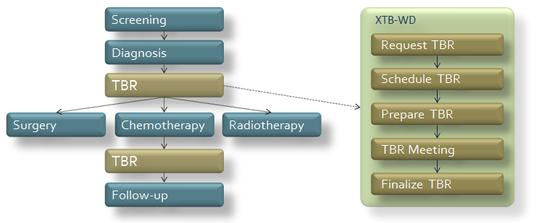

During a care episode, different Workflow Definition documents, some of which are linked together, describe the actual steps of the care pathway. The relative unpredictability of the different steps in a care episode requires a flexible method that allows the total process to be divided into smaller steps. The XTB-Workflow Definition is one of those building blocks. By linking different WD documents, the relation between the different XDW documents can be created.

Instantiation
XTB-WD documents are XDW documents with a specific content. They are created from the XTB-WD template document, and for each workflow and each patient, a new XTB-WD document is created. XDW documents record the task state, input- and output documents for each individual Tumor Board Review (TBR).
Workflow Definition documents can be linked by adding an XDW document as output document. The possibility to refer to other workflow definitions in XDW enables the description of all the steps and processes in complex care pathways through the combination of smaller Workflow Definition documents. In this way, a more flexible and practical workflow description is created, is Appendix A, at the end of this document, shows an example of the nesting / linking of Workflow Definitions.

Deployment
The XTB-WD is easy to deploy: no additional centralized infrastructure is necessary. It is an instantiation of a XDW Workflow Document, which in its turn builds upon the already secured sharing of health documents provided by other IHE profiles such as XDS, ATNA, CT and BPPC.
The XDW actors (Content Creator, Content Updater and Content Consumer) are the main (and currently the only) actors of this profile.

Process Flow

Stages of a Tumor Board Review process

A typical Tumor Board Review (TBR) can be described by the following chronological steps:

- Request TBR
- Schedule TBR
- Prepare TBR
- TBR Meeting
- Finalize TBR

Each step in this Workflow definition is accompanied by input- and output documents, as shown in the schema below:

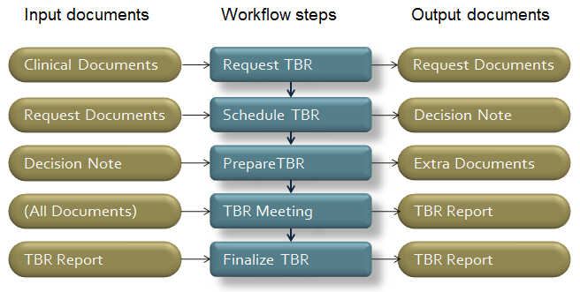

Figure 1 - XTB-WD steps and documents

The steps are explained below.
- Request TBR
If a patient meets the in- and exclusion criteria of a certain Tumor Board Review, the attending physician may decide to present the case to the Tumor Board for review. The owner of this step is called the Requestor. In this step, any documents, images or reports that have led to the diagnosis of the patient may be added as Input Documents for this step. As Output Documents, the Requestor describes the reason for referral, and gives a short description of the patient’s case. Any other medical information can be added as input for the next step.
- Schedule TBR
The owner of this step is called the Scheduler, This can be the chairperson of the TBR, or a medical secretary. The Scheduler reads the request for admission to the TBR, checks the inclusion- and exclusion criteria for the TBR at hand. The Scheduler uses the information that has been attached to the first step for the assessment, and decides whether, and when, the case will be presented in one of the next TBR meetings. The Output Document of this step is the Decision Note, that describe the decision of the Scheduler if, and when, the patient will be presented. This Decision Note can be sent to the requestor. For each requested patient, a decision Note is created. The Decision Notes can be used to create the work list for the next Tumor Board review.
- Prepare TBR
In this phase, all members of the Tumor Board have access to all the images and documents that have been linked to the TBR workflow so far. This information can be used to prepare for the actual meeting. In the case where extra input from any of the members is requested, a second opinion or report may be added to this step as Output Document. Also, if someone wishes to pose a question or a remark on the case, he or she can add this as an Output Documents. This also creates the possibility of a discussion between the members even before the actual TBR Meeting, to increase the efficiency of the actual meeting
- TBR Meeting
In this stage, all members of the Tumor Board convene and discuss the cases that have been scheduled , using all relevant information that has been gathered by the team members. The discussion between members leads to a consensus-based diagnosis, and a recommendation for the further treatment of the patient. These findings and recommendations are written down by a minutes secretary, and must be validated by all participants. This is used as the Output Document of this stage, and is called the Preliminary Tumor Board Report.
- Finalize TBR
In the final phase of the workflow, the Preliminary Tumor Board Report is used to create the Final Tumor Board Report, which is the output Document of this step. This consists of a document with the relevant patient information, the original request of the Requestor, and the information of the Preliminary Tumor Board Report. The exact content of this report may vary between the specific Tumor Boards. The Final Tumor Board Report document can be sent to the designated recipients of the Report, such as the Requestor, the General Physician of the patient, or any other party.

Any type of Tumor Board Review workflow can be described in these five simple steps. As is the case with XDW, each step of the Workflow Definition can be viewed as a black box as far as the execution of the task is concerned.
Xxx hier nog nog verwijzing naar linken van xdw documenten, (protocollen RT)

The Owner of a step can decide how the task is being performed, as long as the defined output documents are being filled in properly. The difference between a TBR for colon cancer and lung cancer lies in the definition of the content of the input- and output documents that are linked to these steps. The actual content of the documents depend on the type of tumor, the agreements between different parties and the technical possibilities to import and export these documents.

Analysis of the current situation
For the correct management of a Tumor Board Review, each of the participants of the Tumor Board should have the possibility to share and manage the patient’s complete clinical picture. Currently, this is not possible, as there are no standardized means of monitoring and managing the different stages of the workflow, or of the information created in these different steps.
The key elements for improvement of the current processes are:
- Managing TBR workflow
- Tracking the relevant events and related documents
- Tracking of the status of each subtask in the workflow
- Access to all relevant images, reports and other documents created in the process
- Linking the created documents to the different steps in the process, thereby defining the context of these documents
Problems with the current processes
In the current situation, problems arise at all of the above stages:
1. Request TBR
Specialists complain about the cumbersome process of gathering the necessary images, reports, and excerpts from their EPR. Currently, texts are faxed (and have to be re-entered into the EPR of the hospital where the TB meeting is held), and images are sent by CD or DVD. The images and reports on these cd’s have to be linked manually to the right patient in the receiving HIS/EPR. This is a time consuming and error-prone process.

2. Schedule TBR
The chairperson of the Tumor Board has to decide whether the patient fits the constraints for the particular TB meeting, and whether all necessary documents and images are available. If the maximum number of patients has been reached, the chairperson has to determine which patients can be postponed to a later TB meeting. These tasks are time-consuming and often require extra phone calls to the requestor. There is no overview of the status of all requests.

3. Prepare TBR
In the current situation, results from diagnostic studies such as CT scans, X-ray images and endoscopic images can only be seen by the radiologist. Faxes have to be copied if someone wishes to prepare the TB meeting beforehand. In most cases, preparation is not possible for most team members except the radiologist.

4. TBR meeting
During the TB meeting, sometimes patients that where scheduled cannot be discussed because DVD’s have not arrived on time, or not at the right address, or have not yet been linked to the patient.
Since the patient come from different hospitals, the medical information is presented in different ways, on different EPR systems. Since most participants have never met the patients they discuss, this can lead to confusion. Also, the notes that are taken during the discussion of a patient can often not be seen or checked by the all participants.
During the TB meeting, a minutes secretary writes down the findings, conclusions and recommendations for treatment of the patient. These texts have to be checked and validated by the chairperson.

5. Finalize TBR
After the TB meeting, the validated findings, conclusions and recommendations are incorporated into a Tumor Board Review Report. The TBR report is then distributed to the Requestor, and often also to the GP of the patient, and any other designated care professional. Currently, this is a time consuming process, with manual insertion of the texts into a document that has is not automatically created or distributed.

Diagrams
<Description of the process flow(s) and sequence diagram(s) covered by this profile in order to satisfy the use cases. If there are detailed behavioral rules that apply to a specific process flow or multiple process flows or descriptions then an appendix may be added as needed>

XDW Content Profile

Actors / Transactions XDW
<Actors are roles that are played by a system. A system may have multiple actors. This section shall contain Actor/Transaction diagrams and an Actor/Transaction table. See below for general guidelines for Actors/Transactions>

The XDW Content Profile is based on three actors, the Content Creator, the Content Consumer and the Content Updater. Content is created by a Content Creator or a Content Updater and is to be consumed by a Content Consumer or a Content Updater. The sharing or transmission of content or updates from one actor to the other is addressed by the use of appropriate IHE profiles described in the section on Content Bindings with XDS, XDM or XDR.
An XDW Content Creator shall be able to create new workflows by creating a new XDW Workflow Document and placing it into a new folder. A Content Updater shall be able to contribute to existing workflows by consuming an existing Workflow Document and replacing it with an updated XDW Workflow Document. A Content Consumer may only obtain and read XDW Workflow Content Documents.
NOTE: the term Content refers to the content of the XDW document itself, and not the input- or output documents that are being referred to in the XDW document.
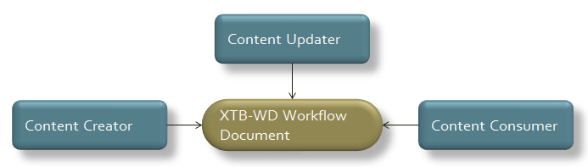
Figure 2 - XDW actor diagram

Cross-Enterprise Document Workflow Profile Options
Options that may be selected for this Profile are listed in the table 30.2-1 along with the Actors to which they apply.
Table 30.2-1 XDW - Actors and Options
Actor | Options | Vol & Section
Content Creator | No options defined | - -
Content Consumer | View Option | ITI TF-1: 30.2.1
Content Consumer | Document Import Option | ITI TF-1: 30.2.2
Content Updater | View Option | ITI TF-1: 30.2.1
Content Updater | Document Import Option | ITI TF-1: 30.2.2

For more details on the XDW profile, see the following documentation:
- IT Infrastructure Technical Framework Supplement Cross-enterprise Document Workflow (XDW)
- IT Infrastructure Technical Framework, Latest Revision

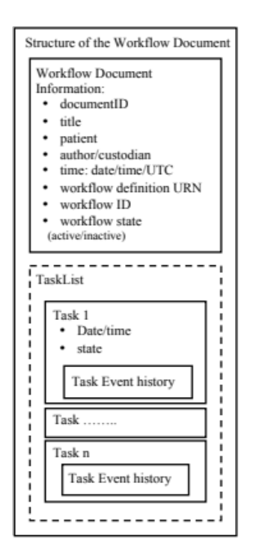
Figure 2.5.3 Workflow Document Structure

XDW Use-Cases and Process Flow in an XDS Affinity Domain
A broad range of use cases may be supported by the XDW Content Profile.
The purpose of this section is to describe a typical use of XDW with no intent to present the breadth and flexibility of XDW. The use case described in this section provides the necessary background to the reader in understanding the basic capabilities of XDW.
The XTB-WD is an example of a Profile defined in the Patient Care Coordination domain, that is based upon the XDW ITI profile.

Cross-enterprise Tumor Board Review Use Case
A typical Tumor Board Review (TBR) can be described by the following chronological steps:

- Request TBR
- Schedule TBR
- Prepare TBR
- TBR Meeting
- Finalize TBR

Each step in this Workflow definition is accompanied by input- and output documents, as shown in the schema below:
Figure 3 - steps and related functional document descriptions

Referral Workflow Use Case - Step by Step
We present below the detailed chronological sequence of steps:
- Request TBR
If a patient meets the in- and exclusion criteria of a certain Tumor Board Review, the attending physician may decide to present the case to the Tumor Board for review. The owner of this step is called the Requestor. In this step, any documents, images or reports that have led to the diagnosis of the patient may be added as Input Documents for this step. As Output Documents, the Requestor describes the reason for referral, and gives a short description of the patient’s case. Any other medical information can be added as input for the next step.
- Schedule TBR
The owner of this step is called the Scheduler, This can be the chairperson of the TBR, or a medical secretary. The Scheduler reads the request for admission to the TBR, checks the inclusion- and exclusion criteria for the TBR at hand. The Scheduler uses the information that has been attached to the first step for the assessment, and decides whether the case will be presented in one of the next TBR meetings. The Output Document of this step is the Decision Note, that describe the decision of the Scheduler if, and when, the patient will be presented. This Decision Note can be sent to the requestor. For each requested patient, a decision Note is created. The Decision Notes can be used to create the work list for the next Tumor Board review.
- Prepare TBR
In this phase, all members of the Tumor Board have access to all the images and documents that have been linked to the TBR workflow so far. This information can be used to prepare for the actual meeting. In the case where extra input from any of the members is requested, a second opinion or report may be added to this step as Output Document. Also, if someone wishes to pose a question or a remark on the case, he or she can add this as an Output Documents. This also creates the possibility of a discussion between the members even before the actual TBR Meeting, to increasethe efficiency of the actual meeting
- TBR Meeting
In this stage, all members of the Tumor Board convene and discuss the cases that have been scheduled , using all relevant information that has been gathered by the team members. The discussion between members leads to a consensus-based diagnosis, and a recommendation for the further treatment of the patient. These findings and recommendations are written down by a minutes secretary, and must be validated by all participants. This is used as the Output Document of this stage, and is called the Preliminary Tumor Board Report.
- Finalize TBR
In the final phase of the workflow, the Preliminary Tumor Board Report is used to create the Final Tumor Board Report, which is the output Document of this step. This consists of a document with the relevant patient information, the original request of the Requestor, and the information of the Preliminary Tumor Board Report. The exact content of this report may vary between the specific Tumor Boards. The Final Tumor Board Report document can be sent to the designated recipients of the Report, such as the Requestor, the General Physician of the patient, or any other party.

Any type of Tumor Board Review workflow can be described in these five simple steps. As is the case with XDW, each step of the Workflow Definition can be viewed as a black box as far as the execution of the task is concerned. The Owner of a step can decide how the task is being performed, as long as the defined output documents are being filled in properly. The difference between a TBR for colon cancer and lung cancer lies in the definition of the content of the input- and output documents that are linked to these steps. The actual content of the documents depend on the type of tumor, the agreements between different parties and the technical possibilities to import and export these documents. The input documents and output documents in the XTB-WD definition are not actual documents, but functional descriptions of the documents. For each referred document in the XTB-WD document, two parameters are described: its functional type, and a reference to the actual document (to be found in the XDS Registry) that fulfills theat function.

XDW Security Considerations
The XDW content profile relies on the security controls in the underlining transport (e.g. XDS). The XDW content is an administrative document that should not include clinical information but administrative information can be just as sensitive as clinical information.
The XDW Workflow Document will be authored by different organizations. As the document is updated the active version will be replaced with a newer version as the workflow progresses. However, with clinical documents it is not expected that organizations will replace documents authored by other organizations, as typically a clinical document comes from only one organization or individual. Therefore in order to adhere to the principle of least privilege organizations want to prevent clinical documents from being replaced by other organizations, while allowing XDW Workflow Documents to be replaced. It is recommended that organizations retain general restrictions on XDS documents, but make an exception for XDW Workflow Documents, based on classCode.
When a Workflow Description Profile is created a risk assessment following the Security Cookbook may result in additional security considerations beyond those for the usual clinical report.

Options for Workflow definitions
<This section contains a table describing the additional capabilities available for this profile and references to all sections that state requirements for compliance to the Option. Options in a Profile are synonomous with options on an automobile in that the purchaser of the automobile may choose the sunroof and upgraded stereo options, but is not required to do so in order to purchase and use the automobile. In another example the purchaser may have the option of an automatic transmission or a manual transmission. In this case the purchaser must choose one option or the other as a car cannot be driven without a transmission.>
The management of the workflow related to clinical processes is becoming a fundamental topic with the increasing use by different sectors of document sharing related IHE profiles with their different types of document and information.

XTB-WD Workflow Definition Profile

Rules for Workflow Definition of XTB-WD
In this chapter a set of rules which defines the workflow of the XTB-WD process and the relationship with the actors involved are described. If real-world scenarious need a technical workflow management the actors involved in the process can use the “Workflow Management” option which groups the XTB-WD actors with the XDW actors.
The ITI XDW profile is a core component of a common, workflow-independent interoperability infrastructure that provides a platform upon which a wide range of specific workflows can be defined by “content specialization” with minimal specification and implementation efforts by the different domains. For the definition of the XTB-WD workflow it is possible to use the ITI XDW profile as an infrastructure layer to define a set logical or clinical tasks definitions and rules to apply. The rules in the workflow definition ensure that the different participants in a workflow operate jointly to advance within tasks and to move from one task to an other in a consistent way.
To integrate the XTB-WD profile with ITI XDW profile it is necessary to introduce the integrations described in the follow paragraphs.

Actors and Grouping
If the “Workflow Management” option is supported the following XTB-WD actors shall be grouped with XDW actors to allow access and manipulation of the XDW-WD (XDW Workflow document).

Actor | Groups with | Note
TBR Requestor | XDW: Content Creator  XDW: Content Consumer  XDW: Content Updater | The TBR Requestor actor shall create the XTB-WD to start the process.  It also consumes and maybe updates the XTB-WD document in case of modification to the Request.
TBR Scheduler | XDW: Content Consumer  XDW: Content Updater | The TBR Scheduler actor consumes and updates the XTB-WD after validation of a TBR Request.
TBR Preparator | XDW: Content Consumer  XDW: Content Updater | The TBR Preparator actor consumes and updates the XTB-WD after adding a comment or question to the discussion thread.
TBR Report Writer | XDW: Content Consumer  XDW: Content Updater | The TBR Report writer actor consumes and updates the XTB-WD after adding the final comment or question to the discussion thread, and creating the Preliminary TBR report document
TBR Finalizer | XDW: Content Consumer  XDW: Content Updater | The TBR Finalizer actor consumes and updates the XTB-WD after ceating the Finalized TBR Report and sending it to the TBR Requestor.

XDW Workflow Document – Common Attributes
The XTB-WD Workflow Definition does not introduce new metadata and all the metadata elements used are the common XDS document metadata specified in ITI TF-3:4.1.5 and in ITI TF-3:5.4.6. In this section only the use of some specific metadata for the use of XDW in the XTB-WD context is specified.

XDSDocumentEntry Attribute | Definition
typeCode | For the Workflow Document which tracks the XTB-WD process the code for the typeCode shall be:  urn:ihe:pcc:xtbwd:2012  This code is the same code that shall be use in the element workflowDefinitionReference inside the Workflow Document
eventCodeList | Rule 1:  An XTB-WD workflow shall be created with code OPEN and shall remain in this status until it is set to CLOSED.  Rule 2:  An XTB-WD workflow should be set to CLOSED when:  - one of the tasks has the status FAILED; or  - when you complete the workflow with the TBR-validation task in status COMPLETED.  See ITI TF-3: 5.4.5.7 for a general description of this attribute.
serviceStartTime | It is the time at which work began on the first task for this workflow.
serviceStopTime | It is the time at which the status of the overall Workflow is changed from OPEN to CLOSED.  It shall be empty when the workflow is still in OPEN state.

Workflow Task Definition
This chapter describes Workflow Tasks which are used in the XDW Workflow document to express a Tumor board Review workflow.

The Tumor Board Review workflow has the following scenario:

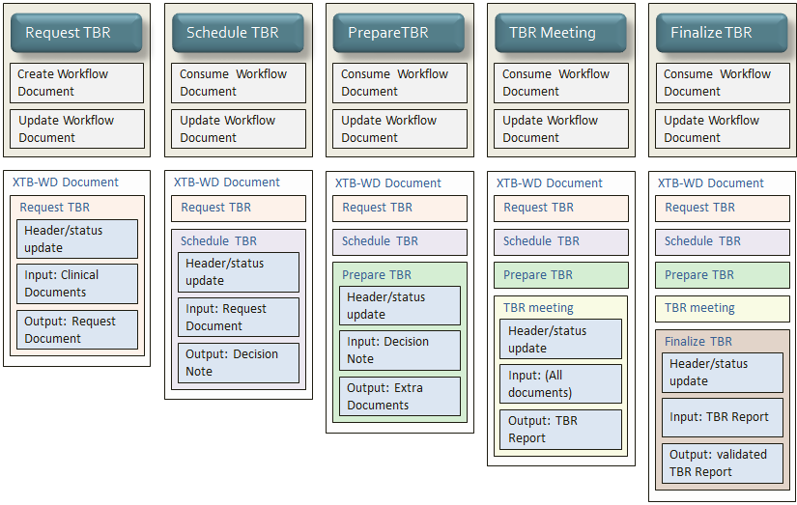
Figure 2 - XTB-WD Workflow Steps and buildup of the XDW document

TBD-VvP: where does this part go to?

Important note: When referencing input and output documents in tasks, both document uniqueId and homeCommunityId of the document shall be used.

Groupings
<This section specifies Actors from other profiles, possibly in other domains, that this profile shall, may or should be grouped with; including any additional requirements placed upon them when grouped with actors of this profile (and vice versa).>
[Volgens mij geen]

Security Considerations
<Description of the Profile specific security considerations. This should include the outcomes of a risk assessment. This likely will include profile groupings, and residual risks that need to be assigned to the product design, system administration, or policy.>
[Volgens mij geen]

Content Modules
<This section defines which document and/or section content module(s) shall be used. Not all profiles will have content in this section. Tables should be used to show data element mappings between different standards. See below for an example from the Antepartum Summary profile mapping ACOG data elements to PCC section templates.>

Table X.7-4 Antepartum History and Physical Content Modules
ACOG Antepartum Record Datum | CDA Section
Drug Allergy/Latex Allergy | Allergies and Other Adverse Reactions
Is Blood Transfusion Acceptable | Advance Directives
Antepartum Anesthesia Consult Planned | Plan of Care
Problems/Plans | Problems
Medication List | Active Medications
EDD Confirmation/18-20 Week EDD Update | Estimated Delivery Dates
Prepregnancy Weight | Visit Summary Flowsheet
Visit Flowsheet | Visit Summary Flowsheet

<Appendix A> Actor Summary Definitions
<add any actor definitions for new actors defined specifically for this profile>

<Appendix B> Transaction Summary Definitions
<add any transaction definitions for new transactions defined specifically for this profile>

Glossary
Add the following terms to the Glossary:
<any glossary additions associated with the profile draft go here>

Volume 2 – Transactions and Content Modules
<A PCC Profile will have sometimes have Transactions, will sometimes have Content Modules, and sometime may have both. Following are guidelines on the content needed in sections for both Transactions and Content Modules.>

IHE Transactions
Add section 3.Y

<Transaction Name>
<This section corresponds to Transaction Y of the IHE Technical Framework. Transaction Y is used by the <ABC> and <DEF> actors. This section may or may not be present depending on the issues the profile addresses.>

Scope

Use Case Roles
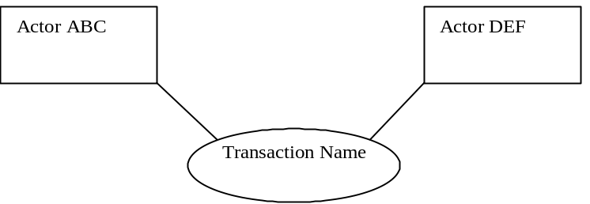
Actor:
Role:
Actor:
Role:
Actor:
Role: .

Referenced Standard
<e.g., HL7 2.3.1 Chapters 2, 3>
<e.g. DICOM 2008 PS 3.3: A.35.8 X-Ray Radiation Dose SR IOD>

Interaction Diagram
<the interaction diagram shows the detailed standards-based message exchange that makes up the IHE transaction>
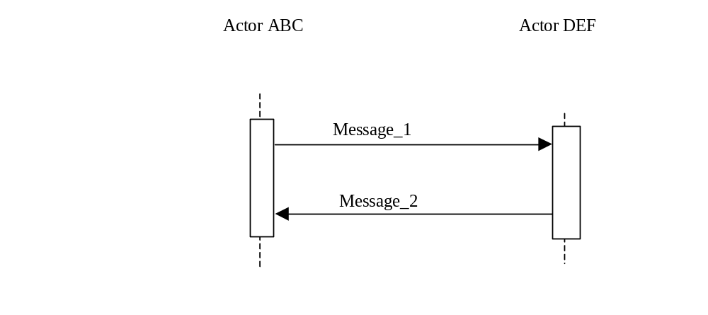

<Message_1 Name>
<One or two sentence description of the first message of the above interaction diagram, typically relating the message to the relevant standard>

Trigger Events
<description of the real world events that cause the initiation of the first message>

Message Semantics
<detailed description of the meaning, structure and contents of the first message including any IHE specific clarifications of the message format, attributes, etc.>

Expected Actions
<description of the actions expected to be taken as a result of sending or receiving this message>

<Message_2 Name>
<One or two sentence description of the the next message in the above interaction diagram, typically relating the message to the relevant standard. Note, repeat this section as necessary based on the number of messages in the interaction diagram>

Trigger Events
<description of the real world events that cause the initiation of the next message>

Message Semantics
<detailed description of the meaning, structure and contents of the next message including any IHE specific clarifications of the message format, attributes, etc.>

Expected Actions
<description of the actions expected to be taken as a result of sending or receiving this message>

Security Considerations
<description of the transaction specific security consideration. Such as use of security profiles. >

Security Audit Considerations
<This section should specifiy any specific ATNA security audit event that is associated with this transaction and requirements on the encoding of that audit event. >

Actor Specific Security Considerations
<This section should specifiy any specific security considerations on an Actor by Actor basis.>

Namespaces and Vocabularies
<This section lists the namespaces and identifiers defined or referenced by the IHE PCC Technical Framework, and the vocabularies defined or referenced therein. Additional namespaces and vocabularies shall be added to the table in the following format. For specific examples see PCC TF-2:5.0>
codeSystem | codeSystemName | Description

IHE Format Codes
<This section contains a table that lists the format codes, template identifiers and media types used by the IHE Profiles specified in the PCC Technical Framework, and also lists, for reference purposes the same values for other selected IHE Profiles from other committees. For specific examples see PCC TF-2:5.1>

Profile | Format Code | Media Type | Template ID
2010 Profiles

PCC Content Modules

Folder Content Modules

Add section 6.2.Y

<Folder Specification Name>
<This section corresponds to Folder Specification Y of the IHE Technical Framework. Folders are typically used to manage content profiles. This section may or may not be present depending on the issues the profile addresses.>

HL7 Version 3.0 Content Modules

CDA Document Content Modules

Add section 6.3.1.A

<Document Content Module Specification Name>
<This section corresponds to Document Content Module Specification A of the IHE Technical Framework. This section may or may not be present depending on the issues the profile addresses.>

CDA Header Content Modules
Add section 6.3.2.B

<Header Content Module Specification Name>
<This section corresponds to Header Content Module Specification B of the IHE Technical Framework. This section may or may not be present depending on the issues the profile addresses.>

CDA Section Content Modules
Add section 6.3.3.C

<Section Content Module Specification Name>
<This section corresponds to Section Content Module Specification C of the IHE Technical Framework. This section may or may not be present depending on the issues the profile addresses.>

CDA Entry Content Modules
Add section 6.3.4.D

<Entry Content Module Specification Name>
<This section corresponds to Entry Content Module Specification D of the IHE Technical Framework. This section may or may not be present depending on the issues the profile addresses.>

PCC Value Sets
Add section 6.5.A

<Value Set Name>
<This section corresponds to Value Set A of the IHE Technical Framework. This section may or may not be present depending on the issues the profile addresses.>

Appendix A – Example of a Nested set of Workflow Definitions

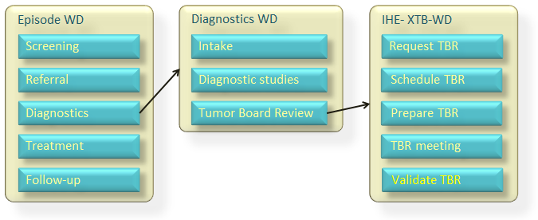

Volume 2 – Transactions and Content Modules
<A PCC Profile will have sometimes have Transactions, will sometimes have Content Modules, and sometime may have both. Following are guidelines on the content needed in sections for both Transactions and Content Modules.>

IHE Format Codes
<This section contains a table that lists the format codes, template identifiers and media types used by the IHE Profiles specified in the PCC Technical Framework, and also lists, for reference purposes the same values for other selected IHE Profiles from other committees. For specific examples see PCC TF-2:5.1>

This profile doesn’t define a new format code. The format code of interest is the one of XDW profile:
Profile | Format Code | Media Type | Template ID
ITI Profiles
Cross Enterprise Document Workflow (XDW) | urn:ihe:iti:xdw:2011:workflowDoc | text/XML | 1.3.6.1.4.1.19376.1.2.3

5.2 IHE Type Codes

Profile | Type Code | Media Type | Template ID
PCC Profiles
Cross Enterprise Tumor Board Workflow Definition (XTB-WD) | urn:ihe:pcc:xtb-wd:2012 | text/XML | 1.2.3.4.5.6.7.8.9.10

PCC Content Modules

Folder Content Modules

In the Cross-Enterprise Tumor Board Workflow Definition Profile, many different documents are created during the clinical process related to the Tumor Board review workflow and every relevant document is referenced in the Workflow Document defined in this profile.
In general, a clinical document can be referenced by many Workflow Documents in different steps and for different reasons. When the content of the Workflow Document is known, the related clinical documents are always reached through the references (XDSDocumentEntry.uniqueId and homeCommunityId) tracked inside the different task in the “input" and “output” elements.
The Folder is the instrument to group all versions of the Workflow Document that are created during the process every time it is updated by the actors involved. The Folder is necessary to have a fixed id to identify the whole workflow. Since the Workflow Document will be replaced many times (it is replaced at each step), its uid/id is not useful for maintaining a fixed reference. Placing all versions of the same Workflow Document into the same folder allows the use of the FolderId as the fixed link to the workflow. The Workflow Document shall be contained in only one Workflow Content Folder within there is only one Workflow Document with Approved status, along with all the previous versions of the same Workflow Document with status Deprecated.
The relationship between the different workflows is always guaranteed to be inside the Workflow Documents using the XDSFolder.uniqueId as output of the task of the parent Workflow Document and as the input of the first task in the child Workflow Document.
This section refers to ITI TF-3: 5.4.5.2.

6.3 XDW Workflow Content Modules

The main instrument of the Cross-Enterprise Tumor Board Workflow Definition Profile is the Workflow Document defined in the XDW Profile. This section provides the key concepts related to the XDW Workflow Document by using a schema and explaining its use. For more detailed, refer to ITI TF-3: 5.4. This document does not include clinical information about the patient directly. It shall only contain information necessary for organizing and defining work tasks. All clinical information regarding any task shall be provided through separate documents that are referenced from the associated input or output documents.

6.3.1 Reference Standard
The Workflow Document is a document that incorporates elements from two international recognized standards:
- HL7 CDA Release 2.0 (denoted HL7 CDA R2, or just CDA, in subsequent text)
- Web Services – Human Task (WS-HumanTask) Specification Version 1.1, OASIS
Since the eReferral process is realted to a cross-enterprise workflow, the Workflow Document described in this profile exists to coordinate the activities and to share the process and the clinical documents of multiple people in different organizations.
The XDW Workflow Document does not contain clinical information about the patient. The input, output, and other elements of the task data shall contain references to documents (XDSdocumentId) that contain the clinical information.
XDW Workflow uses the XDS lifecycle management tools to coordinate updates to the Workflow Document, and shall comply with the XDW XML Schema that includes elements from the CDA and OASIS Human Task standards.
The figure below represents the main level structure of the Workflow Document with the first level of the elements that composed the structure.
It is possible to divide the structured into four parts:
- Part 1: elements derived from HL7 CDA standard (Type of the element: CDA),
- Part 2: two elements, patient and author, defined in the XDWSchema with the structure derived from HL7 R-MIM standard (Type of the element: tXDWpatient and tXDWauthor),
- Part 3: elements defined by IHE XDW Profile
- Part 4: the element <TaskList> in which is defined by elements derived from the OASIS WS-HumanTask standard. In this last section the <TaskList> is a list of elements <XDWTask> composed of the HumanTask <taskData> (all data that define the XDWTask) and the HumanTask <taskEventHistory> that contains a list of elements <taskEvent>.

All the elements of the Figure 6.3.1-1 are briefly described in the Table 6.3.1-1 below, for more detailes refer to ITI TF-3: 5.4.
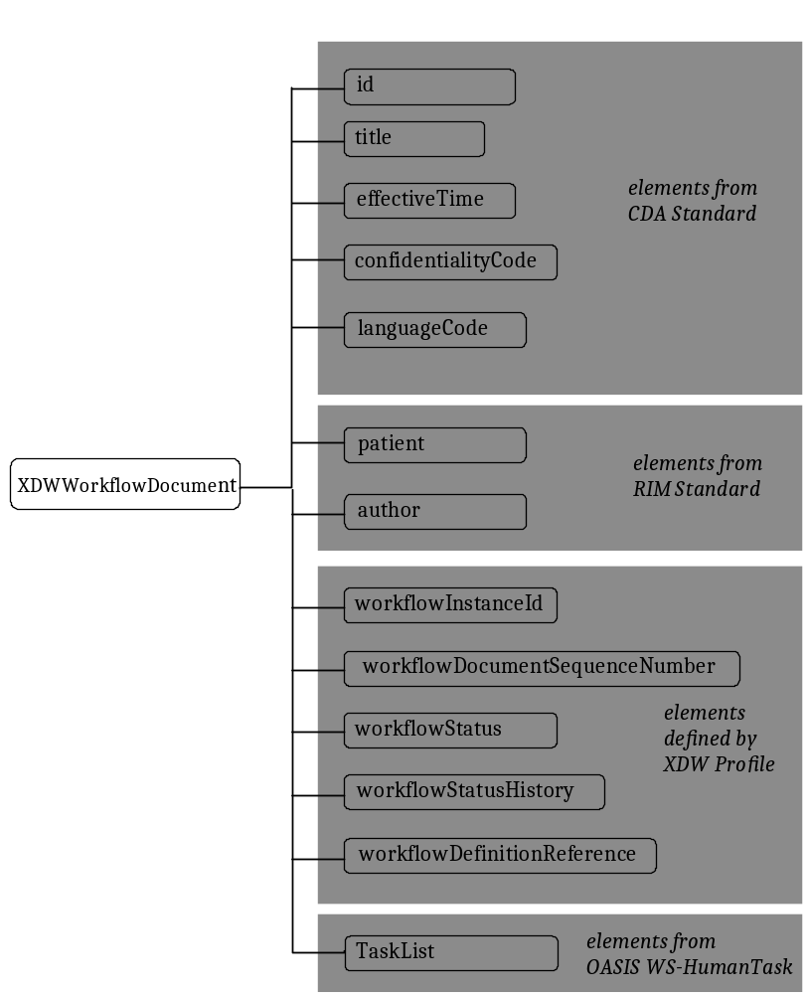
Figure 6.3.1-1 XDW Schema element

Workflow Document Elements | Description | Reference standard | Vol & Section
<id> | Document ID | HL7 CDA R.2.0 | ITI TF-3: 5.4.2.1
<code> | Code defined for the Workflow Documents | HL7 CDA R.2.0 | ITI TF-3: 5.4.2.1
<title> | Display title | HL7 CDA R.2.0 | ITI TF-3: 5.4.2.1
<effectiveTime> | Time of most recent update | HL7 CDA R.2.0 | ITI TF-3: 5.4.2.1
<confidentialityCode> | Code for level of confidentiality of the document | HL7 CDA R.2.0 | ITI TF-3: 5.4.2.1
<languageCode> | Code for the language used to write the document | HL7 CDA R.2.0 | ITI TF-3: 5.4.2.1
<patient> | Element that describe the patient | HL7 R-MIM | ITI TF-3: 5.4.2.1
<autor> | Element that describe the author | HL7 R-MIM | ITI TF-3: 5.4.2.1
<wokflowInstanceID> | instanceID for the version workflow Document | XDW profile | ITI TF-3: 5.4.2.2
<workflowSequenceNumber> | Number of the versione of the Workflow Document | XDW profile | ITI TF-3: 5.4.2.2
<workflowStatus> | Status of the process | XDW profile | ITI TF-3: 5.4.2.2
<workflowDefinitionReference> | Workflow Definition profile of reference | XDW profile | ITI TF-3: 5.4.2.2
<TaskList> | List of the element XDW Task | WS-HT, OASIS | ITI TF-3: 5.4.2.3
Table 6.3.1-1 XDW elements description

6.3.2 Task States Transition

Each tasks added to the Workflow document has a particular state. This states can change during the evolution of the process, and this change is tracked within the <taskEventHistory> element. It’s possible that some tasks born already completed. In the table below we present the task states permitted during the eReferral process.

Task States | Description
CREATED | The task is created but an owner hasn’t been already assigned
IN_PROGRESS | The task is in execution
COMPLETED | The task is completed with response
FAILED | The task is completed with a fault response

6.3.3 Content Modules

Figure 5 - Overview of the different tasks
In this section we define rules and constraints defined for the creation of the XDW Workflow Document related to the Tumor Board Review process.
The set of rules defined here is necessary to manage transition between task. For each task are defined:
- The task attributes: ID, name, type description;
- The sequence of the tasks: the previous and the next task;
- Who is allowed to create each task and to change the status;
- The task event;
- The input and output documents.

The rules in the workflow definition ensure that the different participants in a workflow operate jointly to advance within tasks and to move from one task to an other in a consistent way. It is expected that if an event involves the change of the workflowStatus from OPEN to CLOSED, the process can’t be resumed.
Each feature involves a specific use of the elements that build the Workflow Document.

Task: Request TBR

Task attributes | Rules for the task “RequestTBR”
Task id | Unique id of the instance of the task
TaskType | RequestTBR
TaskName | Request Tumor Board Review
TaskDescription | A tumor board review meeting for a patient is requested by the organiser.
TaskDependencies | Ancestors: None  Successors: Schedule TBR
StatusAllowed | IN PROGRESS  Task ‘RequestTBR’ is being performed by the Owner, but not finished yet.  COMPLETED  Task ‘RequestTBR’ is completed.  FAILED  Task ‘RequestTBR’ has been revoked by the requestor.
StatusTransactions | From IN PROGRESS to COMPLETED or FAILED
Input | - Required  - All relevant documents for the understanding of the case.
Output | - Required  - Request Document.  - Optional  - CCD Document.
Owner | Creator of the Request
OwnerChanges | No
<TaskEvent> | Only one

Example XML for this XDW task:

:
<ns3:taskData>
<!-- <<xxx needs rework after changes to XDW profile definition>>
<ns2:taskDetails>
<ns2:id>urn:oid:1.1.1.1.1</ns2:id>
<ns2:taskType>RequestTBR</ns2:taskType>
<ns2:name> Request Tumor Board Review</ns2:name>
<ns2:status>COMPLETED</ns2:status>
<ns2:createdTime>2006-05-04T18:13:51.0Z</ns2:createdTime>
<ns2:lastModifiedTime>2006-05-04T18:13:51.0Z</ns2:lastModifiedTime>
<ns2:renderingMethodExists>false</ns2:renderingMethodExists>
</ns2:taskDetails>

</ns2:description>

<ns2:input>
<ns2:part name="document">
<!-- Document useful to understand the reason of the Request -->
<!-- uid: the document uniqueId, home: the homeCommunityId -->
<reference uid="urn:oid:1.2.3.4.4.3.2.2.3" home="urn:oid:1.2.3"/>
</ns2:part>
</ns2:input>

<!-- output documents -->
<ns2:output>
<ns2:part name="Request Document">
<!—Request document -->
<!-- uid: the document uniqueId, home: the homeCommunityId -->
<reference uid="urn:oid:1.2.3.4.4.4" home="urn:oid:1.2.3"/>
</ns2:part>
</ns2:output>

</ns3:taskData>

Task: Schedule TBR

Task attributes | Rules for the task “ScheduleTBR”
Task id | Unique id of the instance of the task
Task type | ScheduleTBR
Task name | Schedule Tumor Board Review
Task description | Scheduling the patients for a certain Tumor Board Review Meeting.
Task dependencies | Ancestors: RequestTBR  Successors: PrepareTBR
Status allowed | .  IN PROGRESS  Task ‘ScheduleTBR’ is being performed by the Owner, but not finished yet.  COMPLETED  Task ‘ScheduleTBR’ shall be set to COMPLETED when the request for a Tumor Board Review is accepted by the task owner.  FAILED  Task ‘ScheduleTBR’ shall be set to FAILED when the request for a Tumor Board Review is rejected by the task owner.
Status transactions | From IN PROGRESS to COMPLETED or FAILED
input | - Required  - Request Document.
Output | - Required  - Decision Notice.
Owner | Planner of the TBR [explain role in introduction of this subchapter]
changes of task owner | No
<taskEvent> | Only one

Example XML for this XDW task:

:
<ns3:taskData>

<ns2:taskDetails>
<ns2:id>urn:oid:2.2.2.2.2</ns2:id>
<ns2:taskType>ScheduleTBR</ns2:taskType>
<ns2:name> Schedule Tumor Board Review</ns2:name>
<ns2:status>COMPLETED</ns2:status>
<ns2:createdTime>2006-05-04T18:13:51.0Z</ns2:createdTime>
<ns2:lastModifiedTime>2006-05-04T18:13:51.0Z</ns2:lastModifiedTime>
<ns2:renderingMethodExists>false</ns2:renderingMethodExists>
</ns2:taskDetails>

<!-- input documents -->
<ns2:input>
<ns2:part name="RequestDocument">
<!-- Request Document -->
<!-- uid: the RequestDocument uniqueId, home: the homeCommunityId -->
<reference uid="urn:oid:1.2.3.4.4.4" home="urn:oid:1.2.3"/>
</ns2:part>
</ns2:input>

<!-- output documents -->
<ns2:output>
<ns2:part name="DecisionNotice">
<!-- uid: the DecisionNotice uniqueId, home: the homeCommunityId -->
<reference uid="urn:oid:1.2.3.4.4.5" home="urn:oid:1.2.3"/>
</ns2:part>
</ns2:output>

</ns3:taskData>

Task: Prepare TBR

Task attributes | Rules for the task “PrepareTBR”
Task id | Unique id of the instance of the task
Task type | PrepareTBR
Task name | Prepare Tumor Board Review
Task description | TBR preparation by (individual) participants are made.
Task dependencies | Ancestors: ScheduleTBR  Successors: TBRMeeting
Status allowed | IN PROGRESS  Task ‘Prepare TBR’ is being performed by the Owner, but not finished yet.  COMPLETED  Task ‘Prepare TBR’ shall be set to COMPLETED when all relevant preparation work is done before the TBR meeting.  FAILED  Task ‘Prepare TBR’ shall be set to FAILED when a review of this patient for the TBR meeting is cancelled in this phase.
Status transactions | From IN PROGRESS to COMPLETED or FAILED
Input | - Required  - DecisionNotice
Output | - Optional  - Extra documents necessary for the case.
Owner | TBR participants
changes of task owner | Yes  The owner may change, different participants may add information necessary for the TBR.
<taskEvent> | At least one

Example XML for this XDW task:

<ns3:taskData>

<ns2:taskDetails>
<ns2:id>urn:oid:3.3.3.3.3</ns2:id>
<ns2:taskType> PrepareTBR </ns2:taskType>
<ns2:name> Prepare Tumor Board Review </ns2:name>
<ns2:status>COMPLETED</ns2:status>
<ns2:createdTime>2006-05-04T18:13:51.0Z</ns2:createdTime>
<ns2:lastModifiedTime>2006-05-04T18:13:51.0Z</ns2:lastModifiedTime>
<ns2:renderingMethodExists>false</ns2:renderingMethodExists>
</ns2:taskDetails>

<!-- input documents -->
<ns2:input>
<ns2:part name="DecisionNotice">
<!-- DecisionNotice -->
<!-- uid: the DecisionNotice uniqueId, home: the homeCommunityId -->
<reference uid="urn:oid:1.2.3.4.4.4" home="urn:oid:1.2.3"/>
</ns2:part>

<!-- output documents -->
<ns2:output>
<ns2:part name="Extra documents">
<!-- Extra documents -->
<!-- uid: the ExtraDocuments uniqueId, home: the homeCommunityId -->
<reference uid="urn:oid:1.2.3.4.4.6" home="urn:oid:1.2.3"/>
</ns2:part>
</ns2:output>

Task TBR Meeting

Task attributes | Rules for the task “TBRMeeting”
Task id | Unique id of the instance of the task
Task type | TBRMeeting
Task name | Tumor Board Review Meeting
Task description | TBR meeting with input from relevant participants.
Task dependencies | Ancestors: TBRPreparation  Successors: TBRValidation
Status allowed | IN PROGRESS  Task ‘TBRMeeting’ is being performed by the Owner(s), but not finished yet.  COMPLETED  Task ‘TBRMeeting’ shall be set to COMPLETED when the patient has been discussed during the TBR Meeting.  FAILED  Task ‘TBRMeeting’ shall be set to FAILED when a review of this patient during the TBR meeting has been cancelled.
Status transactions | From IN PROGRESS to COMPLETED or FAILED
input | - Required  - All relevant documents for the TBR Meeting
output | - Required  - TBRReport.
owner | Chairman of the TBR.
changes of task owner | No
<taskEvent> | At least one

Example XML for this XDW task:

<ns3:taskData>

<ns2:taskDetails>
<ns2:id>urn:oid:3.3.3.3.3</ns2:id>
<ns2:taskType> TBRMeeting </ns2:taskType>
<ns2:name> Tumor Board Review Meeting</ns2:name>
<ns2:status>COMPLETED</ns2:status>
<ns2:createdTime>2006-05-04T18:13:51.0Z</ns2:createdTime>
<ns2:lastModifiedTime>2006-05-04T18:13:51.0Z</ns2:lastModifiedTime>
<ns2:renderingMethodExists>false</ns2:renderingMethodExists>
</ns2:taskDetails>

<!-- input documents -->
<ns2:input>
<ns2:part name="All relevant documents for the TBR Meeting">
<!-- All relevant documents for the TBR Meeting -->
<!-- uid: the document uniqueId, home: the homeCommunityId -->
<reference uid="urn:oid:1.2.3.4.4.4" home="urn:oid:1.2.3"/>
</ns2:part>

<!-- output documents -->
<ns2:output>
<ns2:part name="TBRReport">
<!-- TBRReport -->
<!-- uid: the TBRReport uniqueId, home: the homeCommunityId -->
<reference uid="urn:oid:1.2.3.4.4.6" home="urn:oid:1.2.3"/>
</ns2:part>
</ns2:output>

</ns3:taskData>
:

Task Finalize TBR

Task attributes | Rules for the task “FinalizeTBR”
Task id | Unique id of the instance of the task
Task type | FinalizeTBR
Task name | Finalize Tumor Board Review Report
Task description | Finalize the TBR Report and send it to requestor.
Task dependencies | Ancestors: TBRMeeting  Successors: None
Status allowed | IN PROGRESS  Task ‘FinalizeTBR’ is being performed by the Owner, but not finished yet.  COMPLETED  Task ‘FinalizeTBR’ shall be set to COMPLETED when the TBR Report has been completed, validated and is sent to the designated recipients.  FAILED  Task ‘FinalizeTBR’ shall be set to FAILED when a the TBR Report has not been created or has not been approved, and will not be approved in the future.
Status transactions | From IN PROGRESS to COMPLETED or FAILED
input | - Required  - TBRReport
output | - Required  - Finalized TBRReport.
owner | Chairman of the TBR.
changes of task owner | No
<taskEvent> | At least one

Example XML for this XDW task:

<ns3:taskData>

<ns2:taskDetails>
<ns2:id>urn:oid:3.3.3.3.3</ns2:id>
<ns2:taskType> FinalizeTBR</ns2:taskType>
<ns2:name> Finalize Tumor Board Review Report</ns2:name>
<ns2:status>COMPLETED</ns2:status>
<ns2:createdTime>2006-05-04T18:13:51.0Z</ns2:createdTime>
<ns2:lastModifiedTime>2006-05-04T18:13:51.0Z</ns2:lastModifiedTime>
<ns2:renderingMethodExists>false</ns2:renderingMethodExists>
</ns2:taskDetails>

<!-- input documents -->
<ns2:input>
<ns2:part name="TBRReport ">
<!-- Prescription document according to PRE profile -->
<!-- uid: the document uniqueId, home: the homeCommunityId -->
<reference uid="urn:oid:1.2.3.4.4.4" home="urn:oid:1.2.3"/>
</ns2:part>

<!-- output documents -->
<ns2:output>
<ns2:part name="Finalized TBRReport">
<!-- Finalized TBRReport -->
<!-- uid: the FinalizedTBRReport uniqueId, home: the homeCommunityId -->
<reference uid="urn:oid:1.2.3.4.4.6" home="urn:oid:1.2.3"/>
</ns2:part>
</ns2:output>

</ns3:taskData>
:

6.5 Input and output documents

Complete Example

In this section we present a complete example for the Workflow Document at the end of the eReferral process

TBD-VvP: this still has to be rewritten for XTB-WD

<?xml version="1.0" encoding="UTF-8"?>
<ns3:XDW.WorkflowDocument
xmlns:ns1="urn:hl7-org:v3"
xmlns:ns2="http://docs.oasis-open.org/ns/bpel4people/ws-humantask/types/200803"
xmlns:ns3="urn:ihe:iti:2011:xdw"
xmlns:xsi="http://www.w3.org/2001/XMLSchema-instance"
xsi:schemaLocation="urn:ihe:iti:2011:xdw file:C: XDW-2011-09-13.xsd">
<ns3:id root="1.2.3.4.5"/>
<ns3:effectiveTime value="20110401031520"/>
<ns3:confidentialityCode code="1.24.3.3.3"/>
<ns3:patient>
<ns3:id root="1.3.6.1.4.1.21367.13.20.1000" extension="33333"
assigningAuthorityName="IHERED"/>
</ns3:patient>
<ns3:author>
<ns3:assignedPerson>
<ns1:name>
<ns1:family>Brum</ns1:family>
<ns1:prefix>Dr.</ns1:prefix>
</ns1:name>
</ns3:assignedPerson>
</ns3:author>
<ns3:workflowInstanceID>urn:oid:1.2.3.4</ns3:workflowInstanceID>
<ns3:workflowDocumentSequenceNumber>3</ns3:workflowDocumentSequenceNumber>
<ns3:workflowStatus>CLOSED</ns3:workflowStatus>
<ns3:workflowStatusHistory>
<ns3:documentEvent>
<ns3:eventTime>2006-05-04T18:13:51.0Z</ns2:eventTime>
<ns3:eventType>create</ns2:eventType>
<ns3:taskEventIdentifier>urn:oid:1.1.1.1.4</ns2:taskEventIdentifier>
<ns3:author>Mr. Rossi</ns2:author >
<ns3:previousStatus></ns2:previousStatus>
<ns3:actualStatus>OPEN</ns2:actualStatus>
</ns3:documentEvent>
<ns3:documentEvent>
<ns3:eventTime>2006-05-07T09:53:45.0Z</ns2:eventTime>
<ns3:eventType>complete</ns2:eventType>
<ns3:taskEventIdentifier>urn:oid:1.1.1.1.7</ns2:taskEventIdentifier>
<ns3:author>Dr. Brum</ns2:author >
<ns3:previousStatus>OPEN</ns2:previousStatus>
<ns3:actualStatus>CLOSED</ns2:actualStatus>
</ns3:documentEvent>
</ns3:workflowStatusHistory>
<ns3:workflowDefinitionReference>urn:oid:1.2.3.4.5.6.7.8.9</ns3:workflowDefinitionReference>
<ns3:TaskList>
<ns3:XDWTask>
<ns3:taskData>
<ns3:taskDetails>
<ns2:id>urn:oid:1.1.1.1.1</ns2:id>
<ns2:taskType>REQUEST TBR</ns2:taskType>
<ns2:name>Request Tumor Board review</ns2:name>
<ns2:status>COMPLETED</ns2:status>
<ns2:createdTime>2006-05-04T18:13:51.0Z</ns2:createdTime>
<ns2:lastModifiedTime>2006-05-04T18:13:51.0Z</ns2:lastModifiedTime>
<ns2:renderingMethodExists>false</ns2:renderingMethodExists>
<ns2:actualOwner>Dr. Rossi</ns2:actualOwner>
<ns2:createdBy>Dr. Rossi</ns2createdBy>
</ns3:taskDetails>
<ns2:description>code for the type of visit requested</ns2:description>
<ns3:taskInput>
<ns3:documentReference> <!--Lab Report-->
<ns2:identifier>urn:oid:1.2.3.4.1</ns2:identifier>
<ns2:name>Laboratory Report</ns2:name>
<ns2:accessType>urn:IHE:iti:2011:xdw:XDSregistered</ns2:accessType>
<ns2:contentCategory>”URI of the document”</ns2:contentCategory>
<ns2:contentType>XDSDocumentEntry.classCode</ns2:contentType>
<ns2:attachedTime>2006-05-04T18:13:51.0Z</ns2:attachedTime>
<ns2:attachedBy>Dr. Rossi</ns2:attachedBy>
</ns3:documentReference>
</ns3:taskInput>
<ns3:taskOutput>
<ns3:documentReference> <!--eReferral Document-->
<ns2:identifier>urn:oid:1.2.3.4.2</ns2:identifier>
<ns2:name>Request document 1</ns2:name>
<ns2:accessType>urn:IHE:iti:2011:xdw:XDSregistered</ns2:accessType>
<ns2:contentCategory>”URI of the document”</ns2:contentCategory>
<ns2:contentType>XDSDocumentEntry.classCode</ns2:contentType>
<ns2:attachedTime>2006-05-04T18:13:51.0Z</ns2:attachedTime>
<ns2:attachedBy>Dr. Rossi</ns2:attachedBy>
</ns3:documentReference>
</ns3:taskOutput>
</ns3:taskData>
<ns3:taskEventHistory>
<ns3:taskEvent>
<ns3:id>1</ns3:id>
<ns3:eventTime>2006-05-04T18:13:51.0Z</ns3:eventTime>
<ns3:identifier>urn:oid:1.1.1.1.1</ns3:identifier>
<ns3:eventType>create</ns3:eventType>
<ns3:status>COMPLETED</ns3:status>
</ns3:taskEvent>
</ns3:taskEventHistory>
<ns3:XDWTask>
<ns3:XDWTask>
<ns3:taskData>
<ns3:taskDetails>
<ns2:id>urn:oid:1.1.1.1.1</ns2:id>
<ns2:taskType>SCHEDULE TBR</ns2:taskType>
<ns2:name>Schedule Tumor Board review 1</ns2:name>
<ns2:status>COMPLETED</ns2:status>
<ns2:createdTime>2006-05-05T08:53:45.0Z</ns2:createdTime>
<ns2:lastModifiedTime>2006-05-05T08:53:45.0Z</ns2:lastModifiedTime>
<ns2:renderingMethodExists>false</ns2:renderingMethodExists>
<ns2:actualOwner>HIS</ns2:actualOwner>
<ns2:createdBy>HIS</ns2:createdBy>
</ns3:taskDetails>
<ns3:description>code for the type of visit booked and visit info</ns3:description>
<ns3:taskInput>
<ns3:documentReference> <!--eReferral Document-->
<ns2:identifier>urn:oid:1.2.3.4.2</ns2:identifier>
<ns2:name>Request Document</ns2:name>
<ns2:accessType>urn:IHE:iti:2011:xdw:XDSregistered</ns2:accessType>
<ns2:contentCategory>”URI of the document”</ns2:contentCategory>
<ns2:contentType>XDSDocumentEntry.classCode</ns2:contentType>
<ns2:attachedTime>2006-05-05T08:53:45.0Z</ns2:attachedTime>
<ns2:attachedBy>HIS</ns2:attachedBy>
</ns3:documentReference>
</ns3:taskInput>
<ns3:taskOutput>
<ns3:documentReference> <!--Clinical Report-->
<ns2:identifier>urn:oid:1.2.3.4.3</ns2:identifier>
<ns2:name>Decision Note</ns2:name>
<ns2:accessType>urn:IHE:iti:2011:xdw:XDSregistered</ns2:accessType>
<ns2:contentCategory>”URI of the document”</ns2:contentCategory>
<ns2:contentType>XDSDocumentEntry.classCode</ns2:contentType>
<ns2:attachedTime>2006-05-07T09:53:45.0Z</ns2:attachedTime>
<ns2:attachedBy>Dr. Brum</ns2:attachedBy>
</ns3:documentReference>
</ns3:taskOutput>
</ns3:taskData>
<ns3:taskEventHistory>
<ns3:taskEvent>
<ns3:id>1</ns3:id>
<ns3:eventTime>2006-05-05T08:53:45.0Z</ns3:eventTime>
<ns3:identifier>urn:oid:1.1.1.1.1</ns3:identifier>
<ns3:eventType>create</ns3:eventType>
<ns3:status>COMPLETED</ns3:status>
</ns3:taskEvent>
</ns3:taskEventHistory>
<ns3:XDWTask>
<ns3:XDWTask>
<ns3:taskData>
<ns3:taskDetails>
<ns2:id>urn:oid:1.1.1.1.1</ns2:id>
<ns2:taskType>PREPARE TBR</ns2:taskType>
<ns2:name>Prepare tumor Board Review</ns2:name>
<ns2:status>COMPLETED</ns2:status>
<ns2:createdTime>2006-05-07T08:50:00.0Z</ns2:createdTime>
<ns2:lastModifiedTime>2006-05-07T09:53:45.0Z</ns2:lastModifiedTime>
<ns2:renderingMethodExists>false</ns2:renderingMethodExists>
<ns2:actualOwner>Dr. Brum</ns2:actualOwner>
<ns2:createdBy>HIS</ns2:createdBy>
</ns3:taskDetails>
<ns3:description>code for the type of visit</ns3:description>
<ns3:taskInput>
<ns3:documentReference> <!--eReferral Document-->
<ns2:identifier>urn:oid:1.2.3.4.2</ns2:identifier>
<ns2:name>Decision Note</ns2:name>
<ns2:accessType>urn:IHE:iti:2011:xdw:XDSregistered</ns2:accessType>
<ns2:contentCategory>”URI of the document”</ns2:contentCategory>
<ns2:contentType>XDSDocumentEntry.classCode</ns2:contentType>
<ns2:attachedTime>2006-05-07T08:50:00.0Z</ns2:attachedTime>
<ns2:attachedBy>HIS</ns2:attachedBy>
</ns3:documentReference>
</ns3:taskInput>
<ns3:taskOutput>
<ns3:documentReference> <!--Clinical Report-->
<ns2:identifier>urn:oid:1.2.3.4.3</ns2:identifier>
<ns2:name>Clinical Texts</ns2:name>
<ns2:accessType>urn:IHE:iti:2011:xdw:XDSregistered</ns2:accessType>
<ns2:contentCategory>”URI of the document”</ns2:contentCategory>
<ns2:contentType>XDSDocumentEntry.classCode</ns2:contentType>
<ns2:attachedTime>2006-05-07T09:53:45.0Z</ns2:attachedTime>
<ns2:attachedBy>Dr. Brum</ns2:attachedBy>
</ns3:documentReference>
</ns3:taskOutput>
</ns3:taskData>
TBD-VvP: here the nexts tasks: TBRMEETING and FINALIZE_TBR
<ns3:taskEventHistory>
<ns3:taskEvent>
<ns3:id>1</ns3:id>
<ns3:eventTime>2006-05-07T08:50:00.0Z</ns3:eventTime>
<ns3:identifier>urn:oid:1.1.1.1.1</ns3:identifier>
<ns3:eventType>create</ns3:eventType>
<ns3:status>IN_PROGRESS</ns3:status>
<ns3:startOwner>HIS</ns3:startOwner>
<ns3:endOwner>Dr. Brum</ns3:endOwner>
</ns3:taskEvent>
<ns3:taskEvent>
<ns3:id>2</ns3:id>
<ns3:eventTime>2006-05-07T09:53:45.0Z</ns3:eventTime>
<ns3:identifier>urn:oid:1.1.1.1.1</ns3:identifier>
<ns3:eventType>create</ns3:eventType>
<ns3:status>COMPLETED</ns3:status>
</ns3:taskEvent>
</ns3:taskEventHistory>
</ns3:XDWTask>
</ns3:TaskList>
</ns3:XDW.WorkflowDocument>

6.4 Common Attribute

The XTB-WD Workflow Definition does not introduce new metadata and all the metadata elements used are the common XDS document metadata specified in IHE ITI TF-3:4.1.5 and in IHE ITI TF-3:5.4.6. In this section only the use of some specific metadata for the use of XDW in the XBeR-WD context is specified.

XDSDocumentEntry Attribute | Definition
formatCode | For each Workflow Document the formatCode shall be:  urn:ihe:iti:xdw:2011:workflowDoc  with template ID: 1.3.6.1.4.1.19376.1.2.3
typeCode | For the Workflow Document which tracks the XBeR-WD process the code for the typeCode shall be:  urn:ihe:pcc:xberwd:2012  This code is the same code that shall be use in the element workflowDefinitionReference inside the Workflow Document
eventCodeList | Rule 1:  An XBeR-WD workflow document shall be created with code OPEN and shall remain in this status until it is set to CLOSE.  Rule 2:  An XBeR-WD workflow should be set to CLOSE when:  - one of the tasks has the status FAILED;  or  - when the workflow is completed with the Referral Referred task in status COMPLETED.  See IHE ITI TF-3: 5.4.5.7 for a general description of this attribute.
serviceStartTime | It is the time at which work began on the first task for this workflow.
serviceStopTime | It is the time at which the status of the overall Workflow is changed from OPEN to CLOSE.  It shall be empty when the workflow is still in OPEN state.

Input- and Output Documents
In this section we present which kind of documents should be referenced in a input or output sections of each task involved in the eReferral Process.
A document is referenced in the Workflow Document using an element of type: taskData/taskInput/documentReferenced
This element is of type ht:tAttachmentInfo of this element are described in the table below. In this table we explain how to use these attributes to better describe the document referenced:

Attribute Name | type | Description
<identifier> | anyURI | this attribute is valorized with the XDSDocumentEntry.uniqueId of the document OR the XDSFolder.uniqueId of the folder that collects all the versions of other Workflow Document linked to the current process.
<name> | string | name of the document
<accessType> | string | set to value: urn:IHE:iti:2011:xdw:XDSregistered
<contentType> | string | this attribute is valorized with the XDSDocumentEntry.classCode defined by the specific XDS Affinity Domain of reference
<contentCategory> | anyURI | to define
<attachedTime> | dateTime | format of this attribute is:  CCYY-MM-DDThh:mm:ss[Z|(+|-)hh:mm  e.g.:2001-10-26T21:32:52+02:00
<attachedBy> | tUser | this attribute is valorized with the identifier of the actor that attached this document to the task
Table 6.5-1 Attributes of the element AttachmentInfo
All these attributes are required but in the case the value is unknown is possible to leave them empty.
In table 6.5-2 we define the kind of document involved in the eReferral process and defined in the XDS Affinity Domain

Document | contentType | contentCategory
XTB-WD | code defined in the <XDSDocumentEntry.classCode> in the XDS AffinityDomain specific | URI to define
Medical Document | code defined in the <XDSDocumentEntry.classCode> in the XDS AffinityDomain specific | …
Failure Report | code defined in the <XDSDocumentEntry.classCode> in the XDS AffinityDomain specific | TBD-VvP??…

PCC Value Sets
Add section 6.5.A

<Value Set Name>
<This section corresponds to Value Set A of the IHE Technical Framework. This section may or may not be present depending on the issues the profile addresses.>

<Appendix letter> Appendix_Name
<Detailed cross transaction relationships or mapping details are described in an appendix in Volume 2>

The first three documents can be located on the IHE Website at http://www.ihe.net/Technical_Framework/index.cfm#IT. The remaining documents can be obtained from their respective publishers.

